Solution and Dilution Lab
Pre-lab
- Label the first page of the lab PART A. Take notes on the background information, including the equations for Part A
- Paraphrase the procedure for Part A
- Create the data table for Part A
- On the back of your paper, do pre-lab steps 1-3 for Part B (labelling it PART B).

This is a volumetric flask. The ‘shoulder’ is marked. There is an etched line on the neck that indicates the 25.0 mL mark (it is difficult to see here).
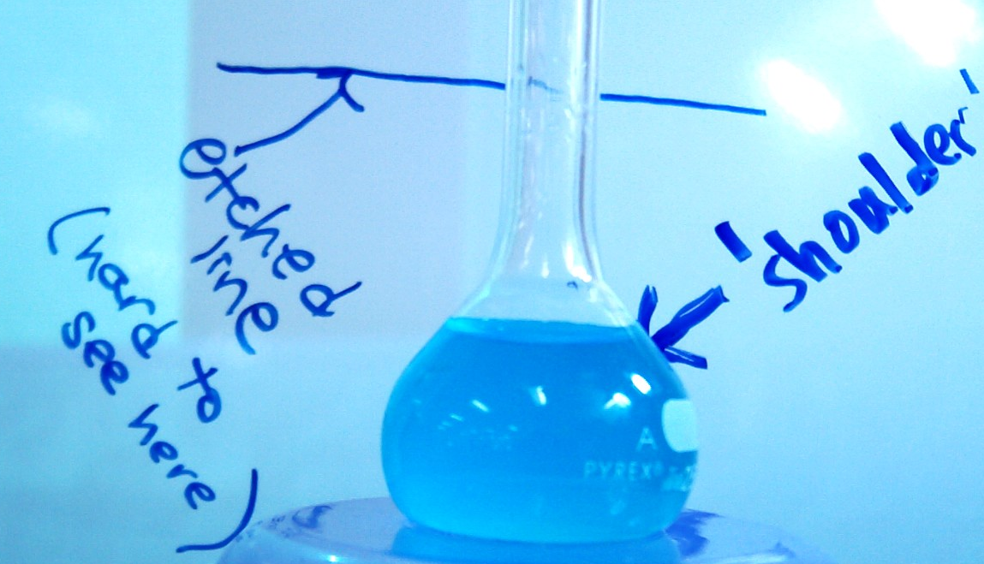

PART A
Background:
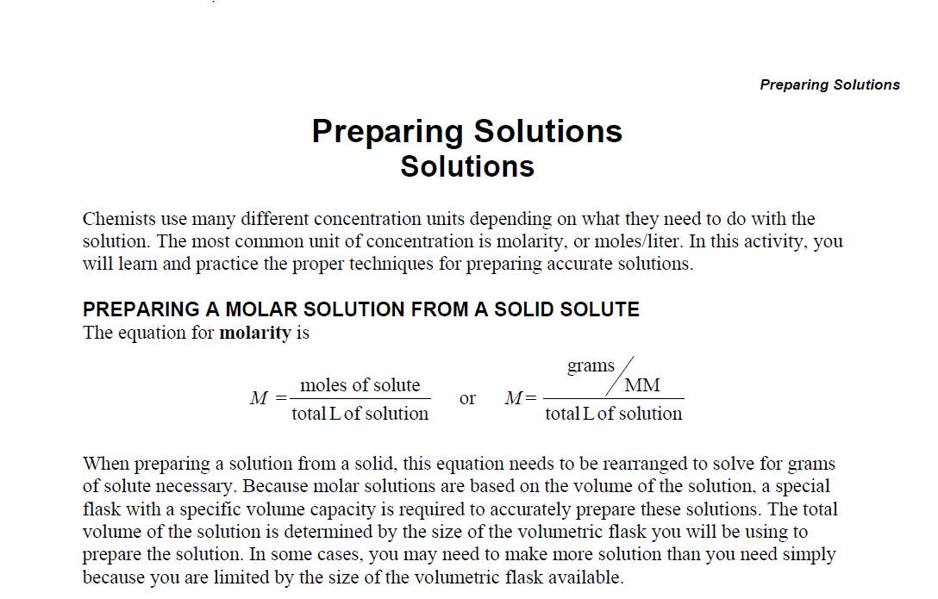

Procedure
- Get a card from your teacher assigning you with a solution to make and a dilution to perform (Part B).
- Using the assigned concentration, calculate the mass of CuSO₄•5H₂O (use molar mass = 249.68 g/mol) that must be dissolved into 50 mL of solution with your assigned concentration (from notecard). [Note: You will do this at the beginning of class when you receive your assigned concentration. Perform this work in the calculations section of the lab.]
- Place the weigh boat on the scale and hit the TARE/ZERO button so that the scale reads ‘0.00.’ Measure the desired amount of solute into the weigh boat. Write down the actual mass measured.
- Transfer the compound to a volumetric flask. The weighboat folds across the diagonal to pour the solid into the flask a bit easier. It might be helpful to have a teammate use a wash bottle to wash the last bits of solid into the flask.
- Add some distilled water to the volumetric flask and wait for the solute to dissolve (it is usually good to add water to the top of the ‘shoulder’ of the flask, just below the stem). Gently swirl the flask to help the solute dissove faster. Once the solute has dissolved, add water until the meniscus is at the etched line of the flask.
- You will now measure the absorbance of your solution, which you will use later to calculate the actual concentration. Only touch the cuvette on the etched sides. Fingerprints on the clear plastic could cause error in your reading. Add some of the solution to the cuvette to rinse the cuvette. (Do not use water.) Dump this solution down the drain. Fill the cuvette with the solution and place the cap on top. Take this solution to the teacher to have the absorbance read. Write down the absorbance in the data table.
Data Table:
Concentration Assigned | Mass of CuSO₄ (g) | Volume of Solution (mL) | Absorbance
 |  | 50.0
PART B
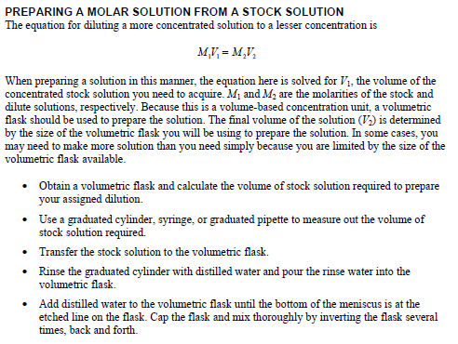
Background

Procedure
- Perform the necessary calculations to prepare the diluted solution. Show all of your work. [Note: You will do this at the beginning of class when you receive your assigned dilution. Perform this work in the calculations section of the lab.]
- Prepare 100 mL of diluted solution according to the techniques described in the introduction.
- Only touch the cuvette on the etched sides. Fingerprints on the clear plastic could cause error in your reading. Add some of the diluted solution to the cuvette to rinse the cuvette. (Do not use water.) Dump this solution down the drain. Fill the cuvette with the diluted solution and place the cap on top. Take this solution to the teacher to have the absorbance read. Write down the absorbance in the data table.
- Clean up: place all chemicals down the drain. Rinse everything. Return materials.

Data Table for Part B
Initial Concentration assigned (from Part A) | Concentration of Dilution assigned | V₁ (mL)  (calculated) | V₁ (mL)  (measured) | V₂ (mL) | Absorbance
 |  |  |  | 100. mL

Calculations:
- Do the calculations assigned in both parts of the procedure in this section, showing all work with units.
- The equation for absorbance based on concentration is: A = (ab)c, where A is the absorbance, c is the concentration (in molarity) and ab is a constant (1.5204). Using the constant provided and your absorbance, calculate the molarity of the solution you made and the dilution you made.

Conclusion Questions (You do not need to rewrite the questions. Write in complete sentences.):
- State the Part A concentration you were assigned and the Part A concentration you experimentally made (based on Absorbance). Why might your concentration be different from the concentration you were assigned to create? Give at least two reasons.
- Calculate the percent error between the actual molarity (the molarity you were assigned to make) and experimental concentration you measured/calculated. Do this for both the Part A solution and the Part B dilution.
- The previous group rinsed their cuvette with distilled water, and a few drops remail. Why is it necessary to rinse the cuvette with a bit of the sample before you place it in the colorimeter and measure Absorbance?
- How would the following error change the concentration of the diluted solution? You added water past the etched line on the volumetric flask. (Be specific. Would the solution’s molarity be greater or smaller than your assigned concentration?)

Part A: Stock Solution  0.10 M CuSO₄ | Part B: Dilution  0.020 M CuSO₄
Part A: Stock Solution  0.15 M CuSO₄ | Part B: Dilution  0.029 M CuSO₄
Part A: Stock Solution  0.20 M CuSO₄ | Part B: Dilution  0.035 M CuSO₄
Part A: Stock Solution  0.25 M CuSO₄ | Part B: Dilution  0.045 M CuSO₄
Part A: Stock Solution  0.30 M CuSO₄ | Part B: Dilution  0.050 M CuSO₄
Part A: Stock Solution  0.35 M CuSO₄ | Part B: Dilution  0.050 M CuSO₄
Part A: Stock Solution  0.40 M CuSO₄ | Part B: Dilution  0.045 M CuSO₄
Part A: Stock Solution  0.45 M CuSO₄ | Part B: Dilution  0.060 M CuSO₄
Part A: Stock Solution  0.50 M CuSO₄ | Part B: Dilution  0.055 M CuSO₄

Per lab group
- Weigh boat with CuSO4
- Empty weight boat
- Scale
- Scoopula
- Wash bottle
- Beaker with distilled water
- 2 vol flasks (100 and 50 mL)
- 2 cuvettes with lids

