**Station** 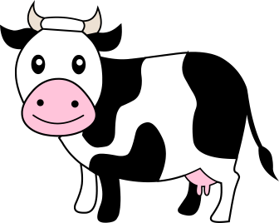

A sample of pure copper was collected and separated based on isotopes. Sample W is Copper-63. Sample Q is Copper-65. Combined, the atomic mass of this sample is 63.4 amu.

1. Calculate the percent abundance of each isotope showing all steps used.
2. Write both of these isotopes of copper in standard isotope notation.
3. What type of force is present in each solid sample? Is this force intramolecular or intermolecular?

[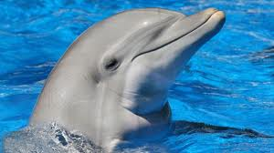](http://www.google.com/imgres?q=dolphin&um=1&safe=active&sa=N&rls=com.microsoft:en-us:IE-SearchBox&biw=1109&bih=550&hl=en&tbm=isch&tbnid=3W-e4HIaKvEaZM:&imgrefurl=http://www.gizmag.com/underwater-dolphin-speaker/22573/&docid=J7MTv6XtxE9UrM&imgurl=http://images.gizmag.com/hero/dolphinspeaker.jpg&w=530&h=297&ei=F0meUpj4NsfbkQfcs4DoBw&zoom=1&iact=rc&page=4&tbnh=140&tbnw=257&start=55&ndsp=20&ved=1t:429,r:61,s:0,i:270&tx=129&ty=52)

**Station**

Use the periodic table to answer the following statements:

1. Record the symbols of the following samples (S, Mg, Ca, O2, Al, Ne, and Zn) in the correct order if they are arranged in order of:
   1. Increasing atomic radius
   2. Increasing electronegativity
   3. Increasing ionization energy
2. What’s the role of electron shielding in effective nuclear charge?

[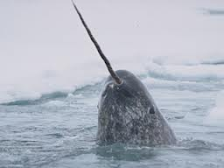](http://www.google.com/imgres?q=narwhal&start=142&safe=active&sa=X&rls=com.microsoft:en-us:IE-Address&biw=1109&bih=550&tbm=isch&tbnid=Gk6rta0dUBhN_M:&imgrefurl=http://www.peggymihelich.com/narwhal-tusk-research-with-martin-nweeia/&docid=ohZzrBs0JVHu3M&imgurl=http://www.peggymihelich.com/wp-content/uploads/2012/03/narwhal-carousel.jpg&w=320&h=240&ei=rUieUs7fLs3fkQeQsIDoBg&zoom=1&iact=hc&vpx=806&vpy=25&dur=1107&hovh=192&hovw=256&tx=172&ty=117&page=8&tbnh=144&tbnw=168&ndsp=21&ved=1t:429,r:47,s:100,i:145)**Station**

Use the dry erase board to help you answer the following questions.

An ion has a charge of -2, a mass number of 81, and 36 electrons.

1. What element is this?
2. How many protons, neutrons, and electrons does this atom have?
3. Write it in standard isotope notation.
4. What is the electron configuration of a neutral atom of this element?
5. Describe what Rutherford learned about the structure of the atom from the experiment shown. Then, draw and label his model of the atom.

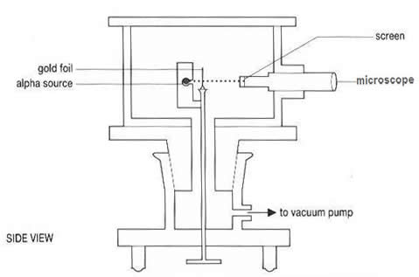

[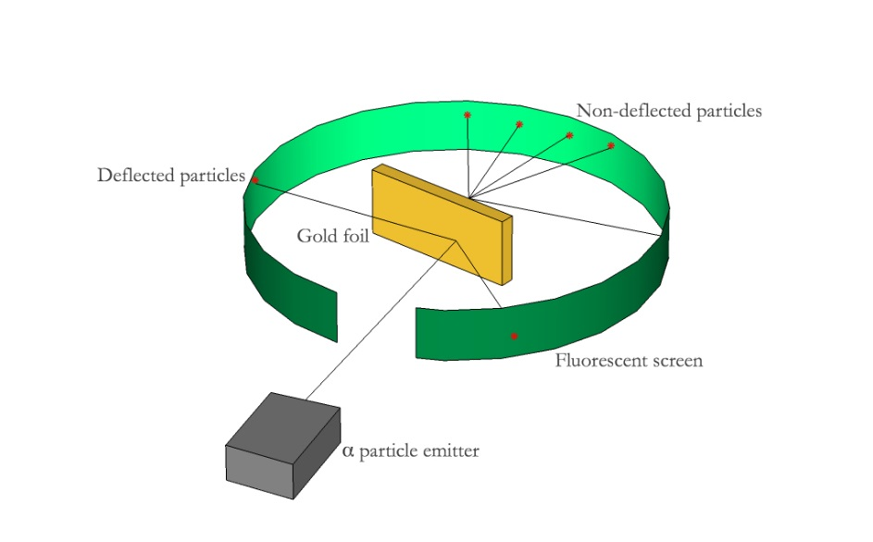](http://padakshep.org/otp/wp-content/uploads/2013/05/rutherford.jpg)

**Station** Llamas

Create the orbital diagram of the electrons in a neutral atom of **nitrogen** by selecting and arranging the cards provided.

1. Draw the result on your answer document.

Several of the available cards have violations of the electron filling rules. Draw an example that would be a violation of each of these rules.

1. Hund’s Rule
2. Pauli Exclusion Principle
3. Aufbau Principle (you have to use at least 2 cards to create this)

[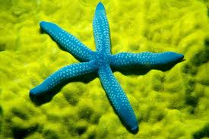](http://www.google.com/imgres?q=starfish&um=1&safe=active&rls=com.microsoft:en-us:IE-Address&hl=en&biw=1109&bih=550&tbm=isch&tbnid=ccPsrz0svawc7M:&imgrefurl=http://fineartamerica.com/featured/blue-starfish-on-poritirs-mitch-warner.html&docid=cbxgt0ucp538CM&imgurl=http://images.fineartamerica.com/images-medium-large/blue-starfish-on-poritirs-mitch-warner.jpg&w=900&h=599&ei=GFKeUqe1L4TtkQfh74GoAw&zoom=1&iact=hc&vpx=787&vpy=254&dur=1810&hovh=183&hovw=275&tx=123&ty=120&page=5&tbnh=133&tbnw=201&start=82&ndsp=21&ved=1t:429,r:96,s:0,i:372)

**Station**

Use the Lewis dot diagram cards to answer the questions.

1. Sort the cards into metals and nonmetals.
2. Identify the family or group of elements to which each element belongs.
3. Which element do you expect to be least reactive? Explain your answer.
4. Choose 2 elements that will become anions and write the ion symbol with charge and the name of the ion.

~~[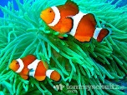](http://www.google.com/imgres?q=clownfish&um=1&safe=active&sa=N&rls=com.microsoft:en-us:IE-Address&hl=en&tbm=isch&tbnid=Fzqib92cIvRLPM:&imgrefurl=http://www.tommyschultz.com/photos/album/philippines/clown-fish-apo-island/&docid=zklQ712rcnaweM&imgurl=http://www.tommyschultz.com/photos/album/philippines/clown-fish-apo-island/clown-fish-apo-island-21.jpg&w=715&h=536&ei=t1GeUrGmEY2pkAfxwYGQDQ&zoom=1&iact=rc&dur=344&page=4&tbnh=133&tbnw=182&start=55&ndsp=20&ved=1t:429,r:64,s:0,i:279&tx=87&ty=41)~~**~~Station~~**

~~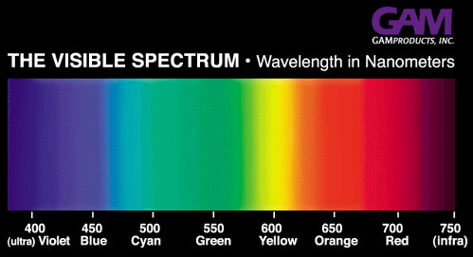~~

~~Using the above chart answer the following questions.~~

1. ~~What is the energy of red light with a wavelength of 700 nm?~~
2. ~~What color of visible light would have a frequency of 7.80 X10~~~~14~~~~Hz?~~
3. ~~Calculate the energy of the EMR with this frequency.~~

**~~Giraffe~~**

~~Ionic bonds~~

~~Roll the blue (cation) and the yellow (anion) block to make an ionic compound. Use this information to fill in row 1. Repeat four more times to fill in the rows for 2 through 5.~~

1. ~~Write the chemical formula for the compound.~~
2. ~~Name the compound.~~

**Parrot**

Examine the samples and answer the following questions:

1. Record the chemical formula for each sample.
2. Name these 3 samples: Pb, O2, and NaCl
3. Write the type of intramolecular force found in each of these substances.
4. Explain how the electrons behave in each type of bond (shared, transferred, sea of electrons).
5. ~~Give~~ **~~two~~** ~~properties of each type of solid.~~

**Oyster**

Get the water molecules out of the plastic container.

1. Draw the Lewis structure for water.
2. What are the bond angles in a water molecule?
3. Identify the force that holds the 2 white “atoms” to the red “atom” in one molecule as intermolecular or intramolecular.
4. Identify the type of IMFs in water.

**Rhinoceros**

1. What is the most electronegative element on the PT?

Roll the nonmetal block and a number dice. The nonmetal element on the block will be one element in the compound and the number on the dice will be how many you have of that element. Roll the block and dice again to get a different, second element and a number. Use this combination as the “compound.”

1. Write the chemical formula for the compound. Write the less electronegative element first using the reference chart below. If the elements have the same electronegativity, write the one in the lowest group first. Ex. Se and C are both 2.55, so C comes first in a formula.
2. Write the name of the compound.
3. Determine the polarity of the **bond** in the compound using electronegativity difference.

|  |  |
| --- | --- |
| Difference in Electronegativity | Bond polarity |
| 0-0.4 | Nonpolar covalent |
| 0.41-1.7 | Polar covalent |
| 1.71- higher | Ionic |

Repeat until you have three different compounds.

E – What else do you need to know about the molecule to determine if it is a polar molecule?



**Electronegativity values in Paulings**

**Emu**

VSEPR Theory

1. Using the Lewis Dot Structures on the green cards provided, identify the number of bonding and nonbonding domains (if any) on the **central atom.** Record them on your answer sheet.
2. Build the shapes using the model pieces in the tubs. Record the names of the shapes and whether it is polar or nonpolar on your answer document.
3. Take apart the models you made. Do not take apart the CO2 and the PBr5.
4. Examine the models of carbon dioxide and PBr5, which are already made for you. Identify the number of electron domains and lone pairs (if any) on the central atom. Name the shapes of the molecules and whether they are polar or nonpolar.

**Atom Model Color Key**

Hydrogen----white

Oxygen----red

Carbon----black

Boron----silver

Fluorine----green

Nitrogen----blue

**Station Ocelot**

Identify the Shape Name and polarity and types of IMFs for the following:

A.



B.

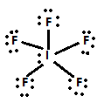

C.

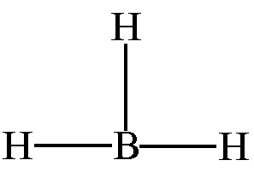

D.

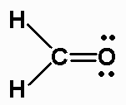

**Moose Station**

Part 1) Using the 3-D molecules, create a table that identifies the shape name, polarity, and types of IMFs for the five models provided.

Part 2)

1. Create a Lewis structure for the molecules below calculate the formal charges.
2. Determine how many bonding domains, non-bonding domains, steric number, and hybridization.
3. Identify the shape of each molecule.

**SO4-2**

**IBrCl4**

**Reindeer Station**

1. Flip the cards over to create the links necessary to answer the following question. Two cards have an error and will not be used. Identify the mistakes made on those cards. After you have correctly arranged the cards, calculate the answer and write it on your answer document.

My stocking has a volume of 2.3 liters. If the density of coal is 3.3 g/mL, and each lump of coal weighs 4.86x107 micrograms, how many lumps of coal will Santa put in my stocking in order to fill it completely full?

1. 3.4 x 104 lumps B. 1280 lumps C. 34 lumps D. 156 lumps
2. Complete the following dimensional analysis problem on your answer document:

Little Josh loves Hanukkah because there are eight nights of gifts. Each night he receives one gift. Each gift is wrapped in a box whose dimensions are shown below. If the roll of Hanukkah wrapping paper is 0.76 meters wide, how many meters of the roll will be used to wrap Josh’s gifts?

1. Calculate the surface area of the gift box. Write the answer down with the appropriate units.
2. Then, work the dimensional analysis problem. The answer is 2.13 meters.

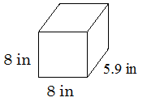

**Skunk Station**

1-octanol looks like this:



It has 8 carbon atoms; that’s where the ‘oct’ in the name comes from. It is “manufactured for use in perfumes and flavorings.”

The energy required to boil 1-octanol is 356 kJ/mol. That means you must supply 356 kilojoules of energy to boil 1 mole of this substance.

Part A) Boiling is a change of state from ____ to ____.

Part B) The molar mass of 1-octanol is 130 grams/mole. Write both fraction-style ratios for this molar mass.

Part C) Use dimensional analysis and your conversion chart to convert 356 kiloJoules/mole into calories/milligram.

**Alligator Station**

Part A) Use the following 4 words to complete the sentences: melting, freezing, condensing, boiling.

When a solid changes to a liquid, that phase change is called _________________ .

When a liquid changes to a gas, that phase change is called __________________.

When a liquid changes to a solid, that phase change is called _________________.

When a gas changes to a liquid, that phase change is called _________________.

Part B)

Josephine and Ray are doing an experiment. They put a thermometer into two liquids and measured the temperatures at which the substances boiled. Their data is below.

|  |  |  |
| --- | --- | --- |
| Substance name | structure | Boiling point |
| ethanol |  | 78.4°C |
| propanal |  | 46.4°C |

1. For each substance, identify the types of intermolecular force(s) holding it together in the liquid state.
2. Which substance has the lower boiling point temperature? Does that mean is has stronger or weaker intermolecular forces than the other substance?
3. Explain why these substances boiled in this order using your knowledge of intermolecular forces.